**Colmers Farm Newsletter**

Dear Parents/Carers,

I trust that you all enjoyed the holidays with your children. It was wonderful seeing everybody back and seeing all of the children settling back into school life so well.

With the new lockdown officially starting yesterday and the seemingly rising number of cases of coronavirus within Birmingham, I would advise that all parents wear a face mask in the playgrounds when dropping off and collecting children. This is optional, but I am recommending this to improve further your safety, and that of others, whilst on the school grounds. Please rest assured that we are continuing to follow our Covid Risk Assessment to ensure that children, staff and visitors to our school are as safe as possible. The most up to date version of the risk assessment can always be found on our school website.

On Tuesday and Wednesday this week, we officially opened out art exhibition to our children. We are really proud of the work that the children produced and I know that both our children and staff really enjoyed and were interested in seeing the art work produced from not only their own year groups, but from across our school. Thank you children for your efforts in creating this fantastic art work and thank you staff for your efforts in teaching this and for displaying the children’s work so creatively. Now as you know, parents and carers, were unable to see this work as you normally would. Although we could not ever fully recreate the experience of you being here to see the exhibition, we have created a video of it for you to watch. This will be appearing on our website and on our Twitter feed today. We hope that you enjoy watching it.

Next week, we will be having a writing week for our children. This will provide staff with the opportunity to focus more on developing children’s writing skills. The children’s writing will be linked to an adventure of the teddy bear in the photo (below). What that adventure will be, will be shared next week. We do have something pretty unique lined up for this teddy though, that nobody at Colmers Farm has ever done before.

Our Member of Parliament (Gary Sambrook) is running a

Christmas card competition that he would like children at

our school to enter. If your child would like to enter this

competition, please see the letter attached to this newsletter.

You are welcome to post the entries yourself or to drop them

into the main office (no later than Monday 16th November)

and we will happily post these for you. For children in KS2,

this could be an opportunity to gain a stamper in your SAGE

award folders/books for the Exploring the Arts section

(if you haven’t gained it already).

I hope that you have a wonderful weekend.

Mr Williams

Friday 6th November, 2020

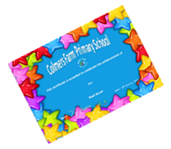

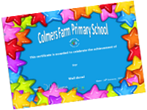

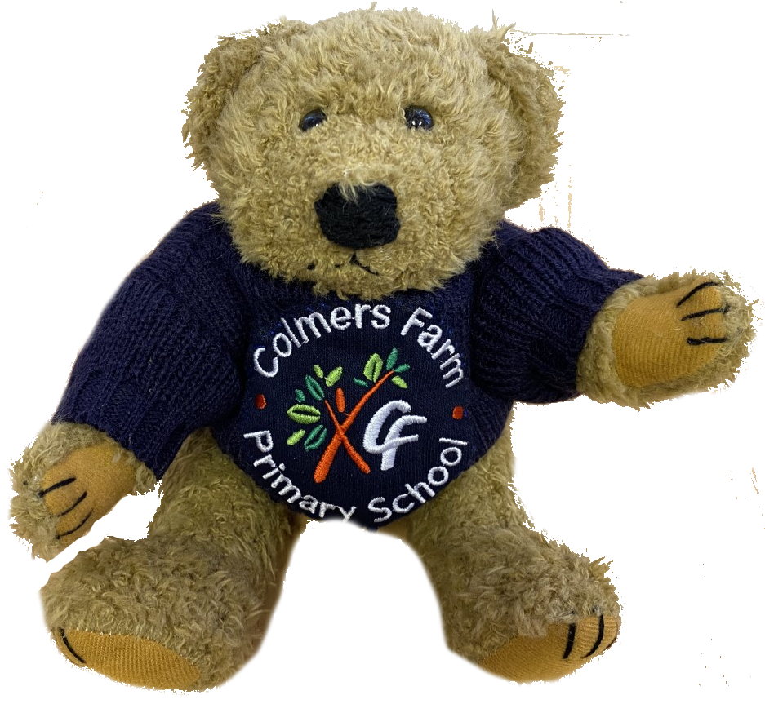



**HOT CHOCOLATE FRIDAY**

Regan and Cayleigh in EYFS, Grace in Year 1, Katieleigh in Year 3, Amber in Yr 4, Dylan and James in Year 5, Kiyanna in Year 6

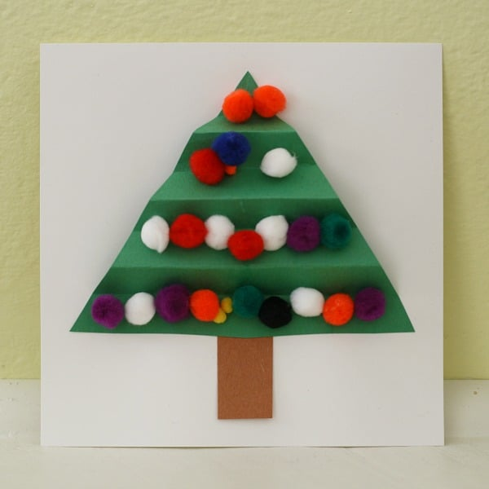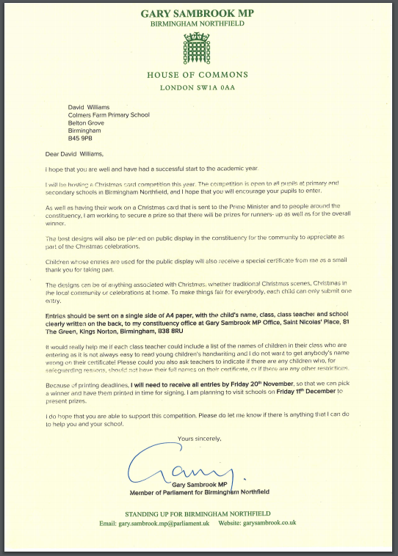



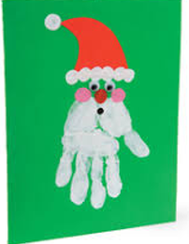

**OUR TREE OF ACHIEVEMENT**

**This week’s winners of the Colmers’ Cat and Colmers’ Camel are:**



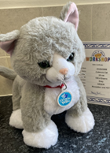

1F

98.3%

2 Lates

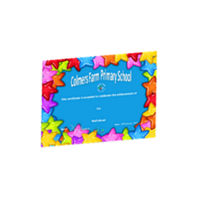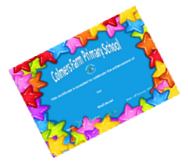

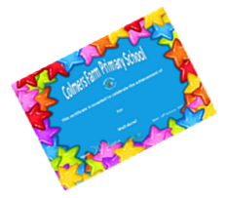



**LOOK WHOSE LEAVES OF ACHIEVEMENT HAVE BEEN HUNG ON OUR TREE THIS WEEK**

in Reception,

Eden and in Year 1, Tahmid and in Year 2,

in Year 3, in Year 4,

in Year 5 and

in Year 6

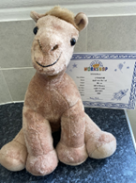

**4J**

**96.5%**

**0 Lates**

**Lilly and Owen in Reception**

**Ella-Mae and Angel in Year 1,**

**Tylor and Zachary in Year 2**

**Iyanna and Nevaeh in Year 3**

**Harry and Logan in Year 4,**

**Madeeha and Reegan in Year 5**

**Kasie and Taliah in Year 6**





[This Photo](http://pngimg.com/download/92862) by Unknown Author is licensed under [CC BY-NC](https://creativecommons.org/licenses/by-nc/3.0/)

**Well Done for your great attendance and punctuality**

**HOT CHOCOLATE FRIDAY**

Due to the Coronavirus, Our Hot Chocolate Fridays can no longer take place with Mr Williams and the children in his office. We are pleased to say that the children will be bringing a Hot Chocolate goodie bag home with them at the end of the day if they were lucky enough to be drawn out

Godpower in RC, Arlo-Jai in 1F,

Scarlet in 2B, Arley-Joe in 3T, Freya in 4J

Roxanne in 5TM and Tennessee in 6D

**WHO WON THE 100%**

**ATTENDANCE RAFFLE TICKET?**

**The winning ticket this week was number 493 and the lucky girl to win the raffle Isabella in**

**Year 2. I wonder what prize she will choose from our prize cabinet?**

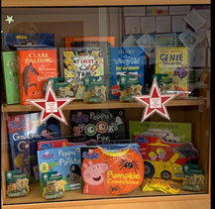





[This Photo](http://kathleenkirkpoetry.blogspot.com/2011/02/true-facts.html) by Unknown Author is licensed under [CC BY-NC-ND](https://creativecommons.org/licenses/by-nc-nd/3.0/)

Well Done

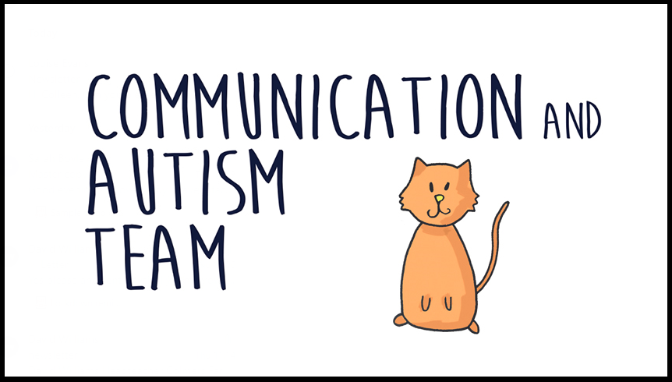



[This Photo](http://www.pngall.com/calendar-png) by Unknown Author is licensed under [CC BY-NC](https://creativecommons.org/licenses/by-nc/3.0/)

**DIARY DATES**

**Monday 16th November**

Odd Socks Day

**Week Commencing 16th November**

Parents’ Evening

**Friday 20th November**

Nurses in school for Flu Nasal Spray

(please return forms back to school even if your child is not having the vaccine, forms still need to be completed and returned)

Lisa Walmsley from Communication Autism Team (CAT) will be joining us for an online coffee to provide parents with information surrounding feeding and toileting difficulties.

**Date: Thursday 26th November**

**Time: 1.15 - 2.15pm**

If you would like to join us please pass your email address onto Mrs Evans (SENCO) so you can be sent a Microsoft Teams invitation.



[This Photo](https://it.wikipedia.org/wiki/File:Cup-o-coffee-simple.svg) by Unknown Author is licensed under [CC BY-SA](https://creativecommons.org/licenses/by-sa/3.0/)

**REMINDERS**

**Please be aware that if you are going to unfortunately be late collecting your child from school, can you please ensure the office is aware of this before 2.50pm so that we can let your child know and prevent them from being distressed.**

**Unless there are pre-authorised exceptional reasons, all children must be collected from their year group door at the correct home time. As you can imagine, Mrs Corbett and Mrs Ayres have a very busy job in the school office and when children are requested to be collected from the office it is time consuming for them and class staff and is disruptive to learning. This sometimes means children would have been quicker to have been dismissed with their class!**

**Children will not be dismissed early unless agreed in advance by a senior member of staff in advance.**

**If your child is late in the mornings, and their entrance door is closed, you must take your child to the school main office for your child to be signed in late. Remember your child should be in school ready for class at 9.00am**

**Please ensure your child/children has a full PE kit in school. Weather is getting colder, so please send your child with jogger bottoms and a warmer top for outside PE.**

DO YOU HAVE A CHILD DUE TO START SCHOOL IN SEPTEMBER?

**APPLY ONLINE FOR YOUR CHILD TO START RECEPTION CLASS IN SEPTEMBER 2021**

**CLOSING DATE 15TH JANUARY 2021**

**VISIT:** [**www.birmingham.gov.uk/schooladmissions**](http://www.birmingham.gov.uk/schooladmissions)

**Online applications will receive an immediate email confirmation when the applications is submitted.**

**If you have any questions about your child starting school, please contact a member on**

**Children’s Services on 0121 303 188 where staff will be pleased to offer assistance.**