Carbon Monoxide (CO) Awareness Initiative- Year 6

Dear Parents/Carers

We are writing to let you know about a very special safety session that is coming up for Year 6 on Tuesday 20th June 2023. It is all about carbon monoxide (CO), understanding what it is and how we can keep ourselves safe. The CO Crew will be visiting your child’s class.

Your child will receive:
  - A CO Crew information booklet (please keep this for reference)
  - A Keyring
  - A Pen

It would be fantastic if you could also read the CO information booklet.

We are aware that safety information can be quite alarming for children and have therefore made a great effort to package all of the information in a child friendly way. That said, if your child does have any concerns about CO, please allay fears. It is highly unlikely that CO is present in your home but none the less, we must work to educate ourselves about its dangers and take precautions to keep ourselves safe, such as fitting a CO alarm.

There is more information about CO in the carbon monoxide booklet that you will receive, or you can visit:

www.cadentgas.com/Emergencies-safety/Suspect-carbon-monoxide

PLEASE NOTE: This information page is aimed at adults and may not be suitable for your child to view.

The CO Crew website has more fun activities for your child to take part in: https://www.thecocrew.co.uk
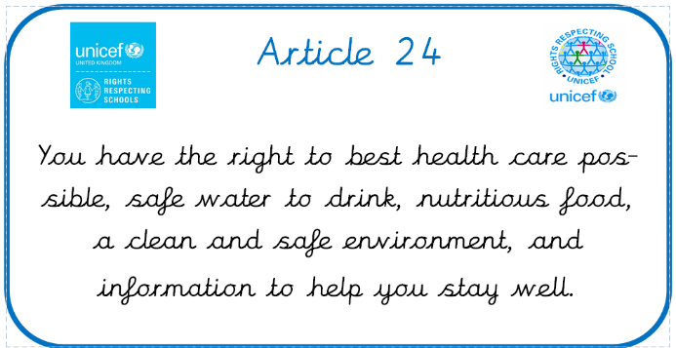
Thank you for your time and if you have any concerns, please don’t hesitate to get in contact.

Yours sincerely,

Miss Cross and Mrs. Greep

