Carbon Monoxide (CO) Awareness Initiative- Year 3

Dear Parents/Carers

We are writing to let you know about a very special safety session that is coming up for Year 2 and 3. It is all about carbon monoxide (CO), understanding what it is and how we can keep ourselves safe. Safety Seymour (a superhero bear) and his safety assistant will be visiting your child’s class, on a mission to rid the world of CO poisoning but he needs your help!! The workshops will take place on Tuesday 20th June 2023 throughout the day.

After the session, your child will be given an Activity Pack to take home with them, it will contain:

  - a CO Alarm
  - a CO information booklet (please keep this for reference)
  - Seymour’s Adventure Trail sheet
  - create your own Safety Seymour 3D figure
  - a Certificate

It would be fantastic if you could assist your child on the Adventure Trail around your home.

We are aware that safety information can be quite alarming for children and have therefore made a great effort to package all of the information in a child friendly way. That said, if your child does have any concerns about CO, please allay fears. It is highly unlikely that CO is present in your home but none the less, we must work to educate ourselves about its dangers and take precautions to keep ourselves safe, such as fitting a CO alarm.

There is more information about CO in the carbon monoxide booklet that you will receive, or you can visit:
www.cadentgas.com/Emergencies-safety/Suspect-carbon-monoxide

PLEASE NOTE: This information page is aimed at adults and may not be suitable for your child to view.
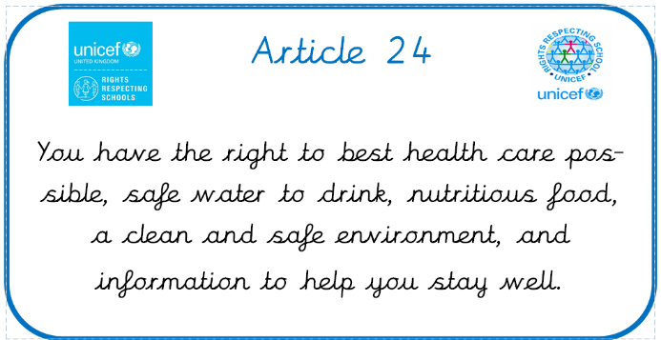
There is also an official Safety Seymour website; it’s full of fun activities for your child to take part in: https://safetyseymour.co.uk.

Thank you for your time and if you have any concerns, please don’t hesitate to get in contact.

Yours sincerely,
Miss Cross and Mrs Greep

